INDIAN BANKING SECTOR
Data Analysis & Business Intelligence Project
Data Cleaning • SQL Analysis • Power BI Dashboard • Audit & Fixes
10,000  Transactions | 3,287  Customers | 10  Banks
₹1.23 Bn  Transaction Value | ₹8.76 Bn  Loan Portfolio | 6  Regions Covered

Portfolio Project — July 2026

1. Introduction
This project takes a raw Indian banking dataset (10,000 transactions, 3,287 customers, 10 banks) through the full analytics pipeline — cleaning, SQL analysis from basic to advanced, and a 6-page interactive Power BI report with button navigation. This document also audits the finished project and documents the real issues found, with fixes.

Tools Used
▸ MySQL — querying & window functions
▸ Power BI — modeling & dashboards
▸ Excel — pivot tables

2. Data Cleaning — Issues & Fixes
Severity | Problem | Fix Applied
Critical | Transaction_Amount stored as text; 288 rows use comma separators (‘20,480.87’) mixed with plain decimals — risks silent truncation if cast to a number without cleaning. | Stripped commas, converted to numeric, and validated the corrected total (₹1.23bn) against the Power BI KPI card.
Moderate | 40 Transaction_IDs are duplicated across two entirely unrelated transactions, breaking the unique-key assumption. | Re-sequenced duplicate IDs so DISTINCTCOUNT measures aren’t understated.
Minor | Loan_Type is NULL for 65% of rows (customers with no loan) — renders as a blank in Power BI slicers. | Replaced NULL with an explicit ‘No Loan’ category.
Minor | Transaction_Date stored as DD-MM-YYYY text — sorts incorrectly as-is. | Converted to a true DATE type via STR_TO_DATE().

3. SQL Analysis — Issues & Fixes
The SQL ranges from basic filters to window functions (running totals, DENSE_RANK top-3 segmentation, regional bank leaderboards) — strong portfolio signal. A few logic bugs were found and fixed:
Severity | Problem | Fix Applied
Critical | Age-band query groups by raw Age instead of the CASE label — returns 59 rows (one per age) instead of 4 meaningful bands, so banding never actually aggregates. | Rewrote with a subquery: compute the band first, then GROUP BY the band label.
Critical | Credit-score tiers use ≤250 / ≤500 / ≤1000, but real scores range 300–900 — ‘Low’ is mathematically unreachable. | Realigned to CIBIL-style bands: Poor <650, Fair 650–699, Good 700–749, Excellent 750+.
Minor | Label bug: 25–40 age band called ‘Men’ (gender term) and 60+ band has typo ‘senior_citizon’. | Relabeled: Young Adult / Adult / Middle-aged / Senior Citizen.

4. Power BI Dashboard
6-page navigable report with a button-driven Home page.
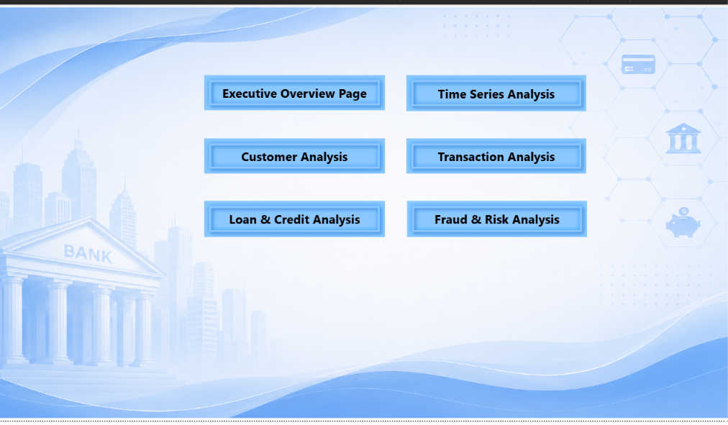
Home — button navigation to all 6 sections
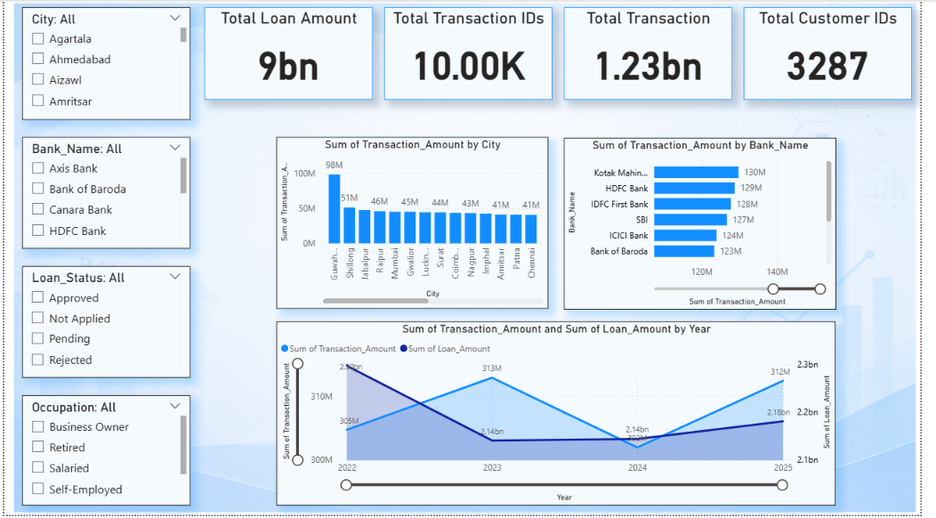
Executive Overview — city, bank & yearly trend
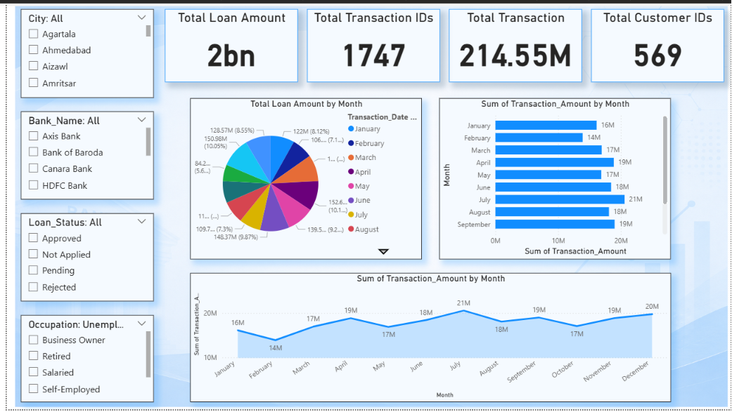
Time Series — monthly loan & transaction trends
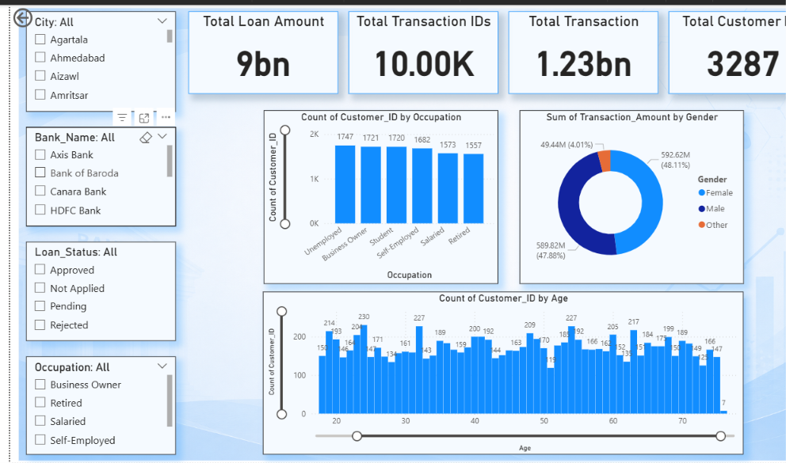
Customer Analysis — occupation, gender, age
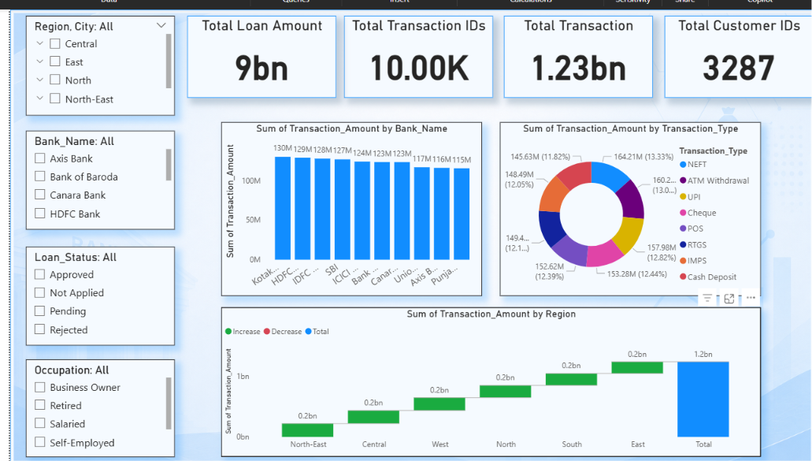
Transaction Analysis — bank, type & regional waterfall
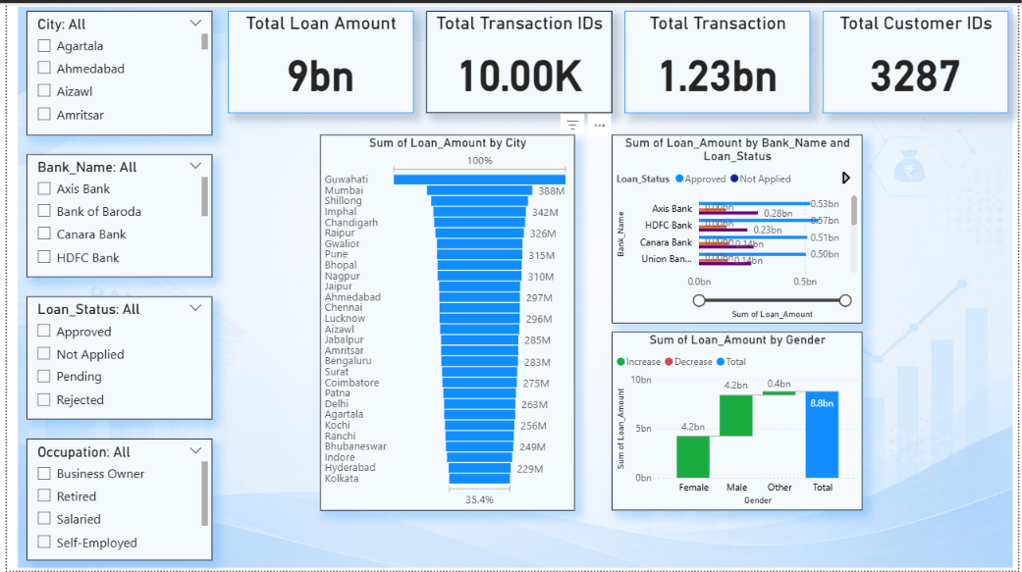
Loan & Credit Analysis — city funnel, bank/status, gender

5. Dashboard Issues — Found & Fixed
Severity | Problem | Fix Applied
Critical | KPI totals inconsistent: Time Series page shows 569 customers / ₹214.55M vs. 3,287 / ₹1.23bn everywhere else — a stray filter left applied. | Cleared filters, reset to report-level totals, added a visible ‘Clear Filters’ button on each page.
Moderate | ‘Fraud & Risk Analysis’ button on the Home page has no matching dashboard page — leads nowhere. | Built the missing page using Fraud_Flag (108 flagged, 1.08%): KPI cards, fraud by region/bank, drill-through table.
Minor | Card titles ambiguous — ‘Total Transaction’ (currency) vs. ‘Total Transaction IDs’ (count) are easy to confuse. | Renamed to ‘Total Transaction Amount’ and ‘Total Transactions’.
Minor | Pie/donut charts used for 8–12 slice breakdowns (month, transaction type) are hard to compare. | Swapped to bar/column charts for >6 categories; reserved donuts for ≤4 categories.

6. Key Insights
▸ ₹1.23bn total transaction value across 3,287 customers and 10 banks.
▸ Near-even gender split by transaction value (48.1% Male, 47.9% Female).
▸ July peaks as the highest transaction-value month in the sampled trend.
▸ Only 1.08% fraud rate — low, but enough to justify a dedicated monitoring page.

7. Future Scope
▸ Build the Fraud & Risk Analysis page to complete the Home page navigation.
▸ Add DAX YoY / MoM growth measures now that dates are typed correctly.
▸ Extend the Excel pivot workbook into a documented appendix — wasn’t available for this review.

8. Conclusion
This project demonstrates the full analyst workflow — cleaning, SQL from basic to advanced, and an interactive multi-page Power BI report — and the audit caught real, specific bugs (a comma-formatting risk, a broken SQL grouping, an unreachable credit tier, a stray filter) each paired with a concrete fix. That combination of build + audit is what makes this a strong portfolio piece.
Review based on the CSV, SQL script, and 6 dashboard screenshots — the .pbix and Excel files didn’t upload; share them directly for a deeper DAX/pivot audit.

